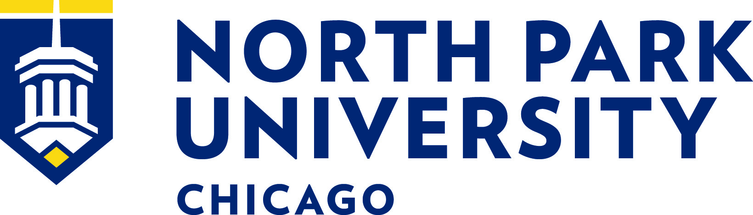

CROSS COUNTRY/TRACK AND FIELD GRADUATE ASSISTANT

Founded in 1891, North Park University is a Christian university affiliated with the Evangelical Covenant Church of over 3,200 students from around the country and world. Located for over 125 years on the land of the Miami and Potawatomi tribes in what is today Chicago’s northside, NPU has recently been designated a Hispanic Serving Institution and is committed to serving diverse populations. Elevating North Park University’s core distinctives of Christian, city-centered, and intercultural, NPU values diversity among its faculty and is committed to building a racially and culturally diverse intellectual community, and strongly encourages the nomination and candidacies of persons who are Black, Indigenous, and People of Color regardless of gender.

MISSION

The mission of North Park University is to prepare students for lives of significance and service through education in the liberal arts, professional studies, and theology.

VISION

Building on our core institutional identity—Christian, city-centered, intercultural—our vision is to create a university of uncommon character and enduring excellence, where faith, learning, and service meet.

North Park University is located in the Albany Park neighborhood of Chicago, one of the most ethnically diverse zip codes in the United States. It is nine miles from downtown Chicago. The North Park campus has often been referred to as an oasis in the heart of the city – a place where students from urban, rural, and suburban backgrounds alike can call home. And all of this within the major metropolitan backdrop of Chicago: one of the world’s largest and most diversified economies, renowned for its museums and music, and voted best large city in the U.S. for four years in a row by Condé Nast Traveler.

North Park University, a member of the College Conference of Illinois and Wisconsin, would like to announce that applications are now being accepted for the position of Cross Country/Track and Field - Graduate Assistant. The assistantship will begin in August 2023 and include tuition remission, a partial meal plan, and a $3,000 stipend per semester.

GENERAL RESPONSIBILITIES:
- Assists the head coach with the daily operations of the cross country and track and field programs at North Park University.
- Analyze performance and instruct athletes in events and techniques in preparation for and during athletics competition.
- Assist with all phases of competitive NCAA and CCIW compliant recruiting.
- Ensure a commitment to the academic success of cross country and track student-athletes, including monitoring academic performance, attendance, and social behavior.
- Build and sustain positive relationships with student-athletes, parents, alumni, faculty, staff, and the campus community.
- Manage equipment usage.
- Complete other duties as assigned by the Head Coach, Assistant Vice President for Athletics and Sport Management, and Associate and Assistant Athletic Directors.

QUALIFICATIONS:
- A bachelor’s degree is required.
- Applicants must be able to work an untraditional work schedule (i.e. frequent nights and weekends).
- Applicant must obtain acceptance in a North Park University graduate program.
- Personal commitment to North Park’s mission of Christian higher education.
- Coaching experience and/or competitive experience in any event area.
- Proficiency in social media (Twitter, Instagram, etc.) and Microsoft Office (especially Excel) is preferred.
- A valid driver’s license is required.

Please complete a North Park University application here.

