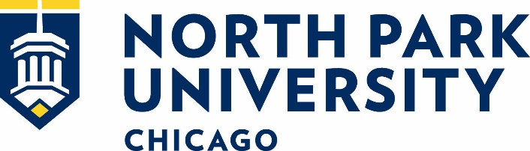

Clinical Coordinator, Direct Entry Masters of Nursing Program (DEMSN)
About North Park:
Founded in 1891, North Park University is a Christian university affiliated with the Evangelical Covenant Church of over 3,200 students from around the country and the world. Located for over 125 years on the land of the Miami and Potawatomi tribes in what is today Chicago’s northside, NPU has recently been designated a Hispanic Serving Institution and is committed to serving diverse populations. Elevating North Park University’s core distinctives of Christian, city-centered, and intercultural, NPU values diversity among its Faculty and is committed to building a racially and culturally diverse intellectual community, and strongly encourages the nomination and candidacies of persons who are Black, Indigenous, and People of Color regardless of gender.
Duties and Responsibilities:
This staff position is the clinical education coordinator and program data analyst for the direct entry master’s in nursing (DEMSN) program. This position is responsible for developing and procuring clinical experience placement, processes, and program information management, including clinical compliance for the School of Nursing and Health Sciences’ DEMSN program. It is a full-time, 12-month position that will report to the Director of DEMSN and the Dean of the School of Nursing and Health Sciences and will work closely with the BSN Program Coordinator for clinical placements.
- Assist with coordinating clinical site experiences per institutional requirements, such as collecting health forms, procuring uniforms, and reviewing certified background checks.
- Serves as coordinator and proctor of Assessment Technology Inc. (ATI) assessments or other Standardized Testing Initiatives
- Assist Faculty in identifying and developing new initiatives to increase DEMSN student practicum opportunities.
- Assist in developing and maintaining mechanisms to communicate practicum policies and experiences to students, academic advisors, program directors, and faculty coordinators.
- Manage and administer student and alumni surveys to monitor program satisfaction, job placement, and employer satisfaction across SNHS programs.
- Manage information systems and databases of student information.
- Handle state and national reports for admission and enrollment demographics and unique information.
- Analyze student data as needed and assist in trending data on student performance within the program.
- Utilize knowledge of informational technologies to assist colleagues.
- Assume student advisement for a select number of pre-nursing students.
- Coordinates clinical compliance for the MSN programs
- And any other duties as assigned.
Qualifications:
The DEMSN Program Clinical Coordinator will possess a baccalaureate degree (master’s preferred) minimally in the health and/or human services area or have had experience in these areas.
The DEMSN Program Coordinator will demonstrate:
- Alignment with the university philosophy, mission, and vision.
- Personal commitment to North Park’s mission of Christian higher education.
- Creative, innovative, and strategic thinking, as well as the ability to work independently and with faculty and students
- Ability to anticipate future trends and challenges and plan accordingly
- Proficiency in Microsoft Office and advanced skills in MS Excel
- Excellent communication skills
- Adaptability and flexibility; with the ability to prioritize and respond effectively to multiple demands
- Ability to collect and analysis data sets
Complete the online application.

