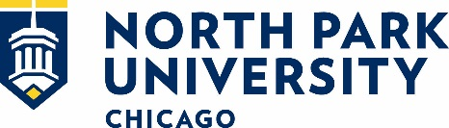
Recent Graduate Career Outcomes
Career Development and Internships Office (CDIO)
North Park University is committed to the long-term success of its students. The Career Development and Internships Office, faculty, and staff all play a crucial role in ensuring our students understand their career pathway options throughout their undergraduate experience.

Spring 2019 Grad Outcomes
227 STUDENTS REPORTING
70% had a job related to their field of study 3 months prior to graduation or intend to pursue graduate school.
26% had secured employment related to their field of study. 44% planned to pursue graduate school upon graduation. 77% reported completing internships during their time at North Park.

Fall 2018 Grad Outcomes
95 STUDENTS REPORTING
85% had a job related to their field of study 3 months prior to graduation or intend to pursue graduate school upon graduation.
39% had secured employment related to their field of study. 46% planned to pursue graduate school upon graduation. 69% reported completing internships during their time at North Park.

* The information below was self-reported by North Park University seniors approximately three months prior to graduation.

All students who indicated that they did not currently have employment or plan to attend graduate school were provided with a list a services and opportunities from the University to support them in their career-planning process, even after graduation.

Updated November 18, 2019

